**21.Implement the Opening technique as a Morphological operation to dilate the foreground regions based on Open CV.**

**AIM:**

**To implement the Opening technique as a Morphological operation to dilate the foreground regions based on OpenCV in Python.**

**PROCEDURE:**

**1. Install OpenCV (if not already installed): install opencv-python**

**2. Import required libraries**

**3. Read the image**

**4. Convert the image to grayscale**

**5. Apply the Opening technique using a kernel**

**6. Display the images**

**7. Wait for a key press & close windows**

**PROGRAM:**

**import cv2**

**import numpy as np**

**image = cv2.imread('image.jpg') # Replace 'image.jpg' with your image path**

**gray_image = cv2.cvtColor(image, cv2.COLOR_BGR2GRAY)**

**kernel = np.ones((5,5), np.uint8)**

**opened_image = cv2.morphologyEx(gray_image, cv2.MORPH_OPEN, kernel)**

**cv2.imshow('Original Image', image)**

**cv2.imshow('Opened Image', opened_image)**

**cv2.waitKey(0)**

**cv2.destroyAllWindows()**

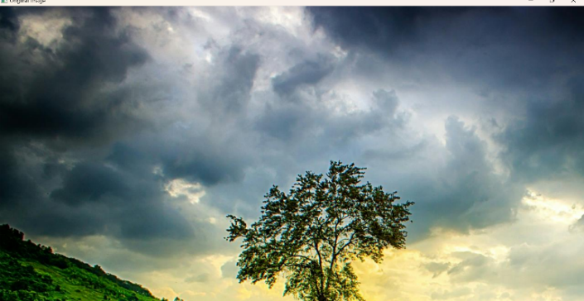**INPUT:**

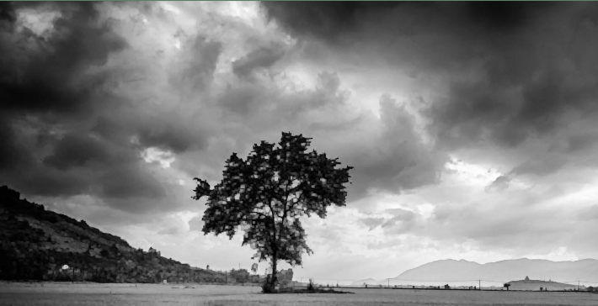**OUTPUT:**

**RESULT :**

**Successfully implemented the Opening technique as a Morphological operation to dilate the foreground regions based on OpenCV in Python.**